UAT Plan

for

Tilt Rush

Index

1. Scope 3

1.1. Objectives and business requirements 3

1.2. Scope 3

2. Testing team 4

3. Environmental requirements 5

3.1. Hardware requirements 5

3.2. Software requirements 5

4. Test Scripts 1

# Scope

## Objectives and business requirements

In this section, outline the business requirements. In other words:

* What are our goals? What are we hoping to accomplish with this project/feature?
* How will we measure success?

The goal for this sprint is to have made both a tutorial screen and a settings screen, both of which connect back and forth between the homescreen. Besides a back button, the tutorial screen will have images and text explaining the gameplay. The settings screen will also have a back button, a ball coulor change, and a level theme selector. Success will be measured through the connections of the pages working, and the coulor preferences changing when clicked and based on time, as well as saving between sessions.

## Scope

In this section, outline the scope. This means:

* What is the pain point we’re trying to fix?
* What are we testing exactly, and what are we *not* testing?

This sprint is aiming to finish everything in the app not in the gameplay, finalising the layout and coulor schemes. This sprint does not include anything under the “play” button, and will not be doing the html sanitizer.

## System Diagrams

In this section, paste any drawings or diagrams that help the UAT team understand the program being tested. With each drawing include a brief explanation of how the drawing represents the application or system being tested.

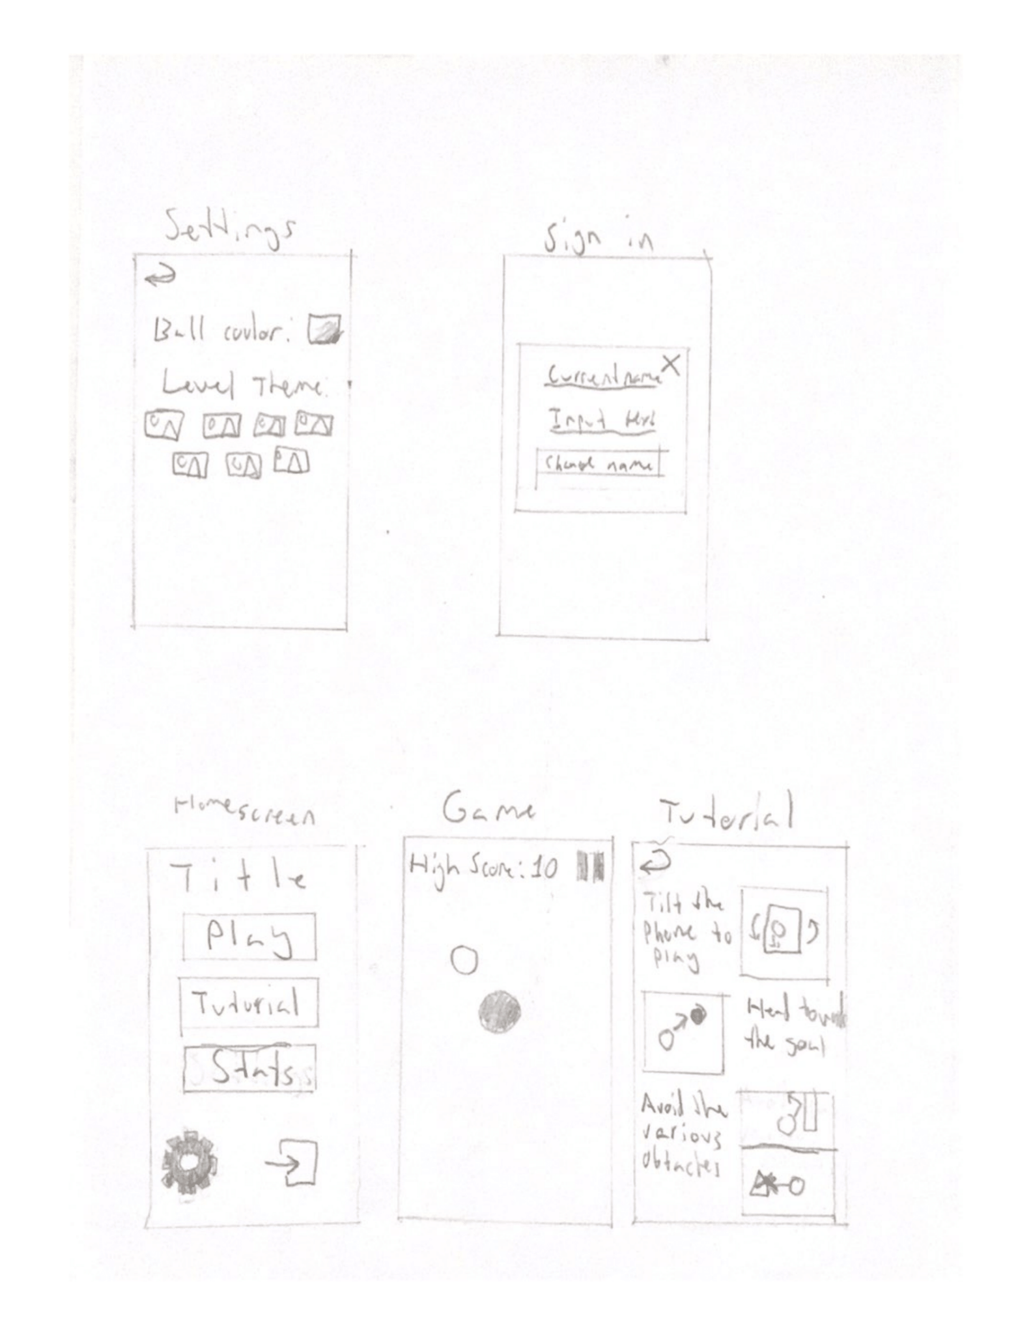

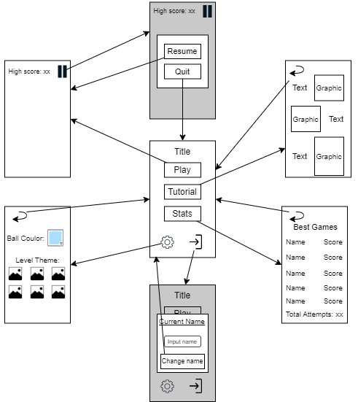

# Testing team

In this section, list out members of your QA team and what their roles will be during UAT.

Example:

| **Name** | **Responsibilities** |
| --- | --- |
| Matheus Pincus | Make sure that the settings and tutorial page function correctly, and that the settings are properly in local storage. |
| Kane Arriagada | Make sure that the settings and tutorial page function correctly, and that the coulor changes with the time of day. |

# Environmental requirements

## Hardware requirements

What hardware has the solution been designed for and should be tested on.

If that is the case, outline the minimal and recommended requirements so the QA team can verify that the software runs on the testers’ machines.

Phone with online capabilities.

## Software requirements

If any extra software or dependencies must be downloaded and installed, list them here.

* Google Chrome (or similar browser)

## Network requirements

Some software (design, video editing…) can be demanding on hardware specifications.

If that is the case, outline the minimal and recommended requirements so the QA team can verify that the software runs on the testers’ machines.

* Working internet connection

# Test Scripts

This section is more important than it seems—it is crucial that both the QA team and the testers know what features must be tested, especially if you’re testing a lot at once.

| **Test** | **Describe the feature being tested** | **Describe the user input or test data** | **Describe the pass criteria** |  |
| --- | --- | --- | --- | --- |
| 3.1 | Tutorial page | 1. Open app 2. Press tutorial button 3. Press back button | 1. Buttons link between home screen and tutorial page 2. Tutorial visuals are visible similar to sketch | Tester name: Matheus Pincus   |  | PASS | | --- | --- | |  | FAIL |   Observations:  .  Tester name: Kane Arriagada   |  | PASS | | --- | --- | |  | FAIL |   Observations: |
| 3.2 | Settings page | 1. Open app 2. Press settings button 3. Change ball coulor 4. Press all level theme buttons 5. Press back button 6. With a changed level theme, check all other working screens | 1. Buttons link between home screen and settings page 2. Ball coulor changer works 3. All level theme buttons can be pressed and change screen coulor 4. All other screens change coulor with level theme | Tester name: Matheus Pincus   |  | PASS | | --- | --- | |  | FAIL |   Observations:    Tester name: Kane Arriagada   |  | PASS | | --- | --- | |  | FAIL |   Observations: |
| 3.3 | Colour changes with time | 1. Wait for, or change time to 8pm-4am, 5-9am, 10am-4pm, and 5-7pm | 1. At 8pm-4am the coulors should be at their darkest 2. At 5-9am and 5-7pm the coulors should be in between 3. At 10am-4pm the coulors should be at their lightest | Tester name: Kane Arriagada   |  | PASS | | --- | --- | |  | FAIL |   Observations: |
| 3.4 | Colour saved locally | 1. Change both settings in settings page 2. Reload page 3. Delete and re-open page | 1. Settings are saved after both checks | Tester name: Matheus Pincus   |  | PASS | | --- | --- | |  | FAIL |   Observations: |

Write step-by-step, detailed but concise instructions on how to test the feature.